From Eastern Connecticut (I-95 Southbound)
- take exit 47 (Rte. 34 connector)
- stay on connector until it ends
- proceed straight until road ends at the junction with
Ella Grasso Boulevard
- take a right onto the Boulevard and move quickly to the left lane
- at the first intersection, take a left onto Rte. 34 and continue west on
Rte. 34 (approximately 5 miles)
- follow signs for Route 34 West (Note: In Derby, Rte. 34 makes a hard left turn and passes under Rte. 8 overpass.)
- see Getting Close directions below

From Southwestern Connecticut (I-95 Northbound)
- take exit 27 to Rte. 8 North
- from Rte. 8, take exit 15
- at end of ramp, turn left onto Rte. 34
- see Getting Close directions below

From the North on Rte. 8 (Southbound)
- take exit 15
- at end of ramp, turn left onto Main St. (Rte. 34)
- see Getting Close directions below

From the South on Rte. 8 (Northbound)
- take exit 15
- at end of ramp, turn left onto Main St. (Rte. 34)
- see Getting Close directions below

From the Wilbur Cross/Merritt Parkway (Rte. 15 Northbound)
- take exit 52 onto Rte. 8 North
- from Rte. 8, take exit 15
- at end of ramp, turn left onto Main St. (Rte. 34)
- see Getting Close directions below

From the Wilbur Cross Parkway (Rte. 15 Southbound)
- take exit 58 (2nd exit after West Rock Tunnel) and go right on Rte. 34 (west)
- follow signs for Route 34 West (Note: In Derby, Rte. 34 makes a hard left turn and passes under Rte. 8 overpass.)
- see Getting Close directions below

Getting Close
- Downtown Derby: from Main Street Rte. 34/Rte. 8 intersection (overpass)
- continue West on Rte. 34 for about 1.5 miles
- take a right onto Lakeview Terrace (there is a road sign for Kellogg Center/Osbomedale State Park at the corner)
- continue to stop sign at the end of the road
- turn left at stop sign. Our parking lot is on your left. Welcome!

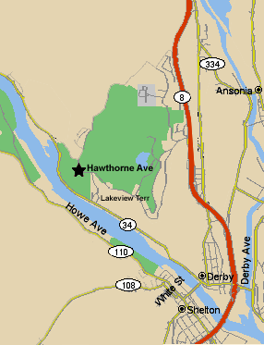

CT Dept. of Environmental Protection
Kellogg Environmental Center
Osborne Homestead Museum

500 Hawthorne Avenue, Derby, CT 06418
(203) 734-2513 FAX (860) 622-2648

