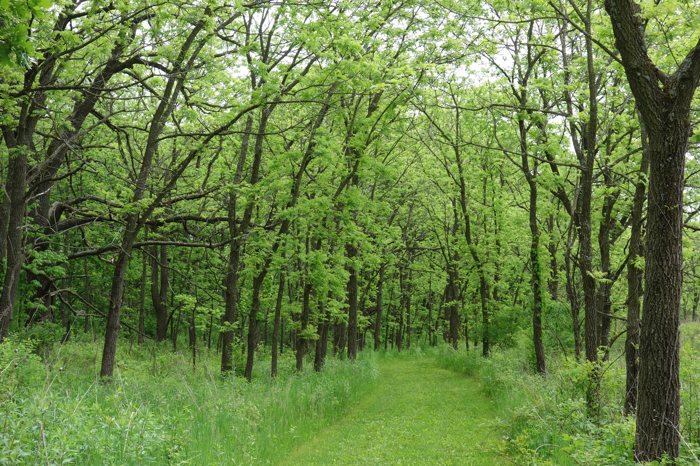
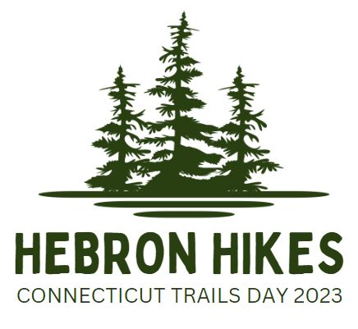

Hebron Trails Passport Program
June 1, 2024 – July 6, 2024

Help us celebrate Connecticut Trails Day with the Hebron Trails Passport program. This program is designed to get you out to visit and explore some of the Town of Hebron’s most beautiful open space properties. Pick up your Passport on June 1st from 9a-12p at the Hebron Farmers and Artisans Market located at Hebron Elementary School*. From there, you have one month to visit and explore the seven properties located on the passport. Stamp each property that you visit with the stamp located somewhere in a clearly marked area of the trail...maybe at the beginning, maybe in the middle, maybe at the end! Bring your stamped Passport to the Hebron Farmers and Artisans Market on July 6th to receive a prize!

To kick off the Hebron Trails Passport program, join us for a guided hike beginning at 10:30am at the old Way Property located at approximately 171 Jagger Lane. This is a great opportunity to complete your passport stamp while discovery a property rich in farming history with woodlands diversity and open meadows. Meet at the new trailhead and park in the designated lot or on the side of the road. The trail is an easy to moderate 1-2 mile round trip with some muddy and overgrown areas. Allow 1 hour to enjoy this hike.
For additional information call 860-530-1281

*If you are unable to pick up your passport on June 3rd, they will be available in the Parks and Recreation office at Burnt Hill Park from 10a-2p Monday-Thursday.
