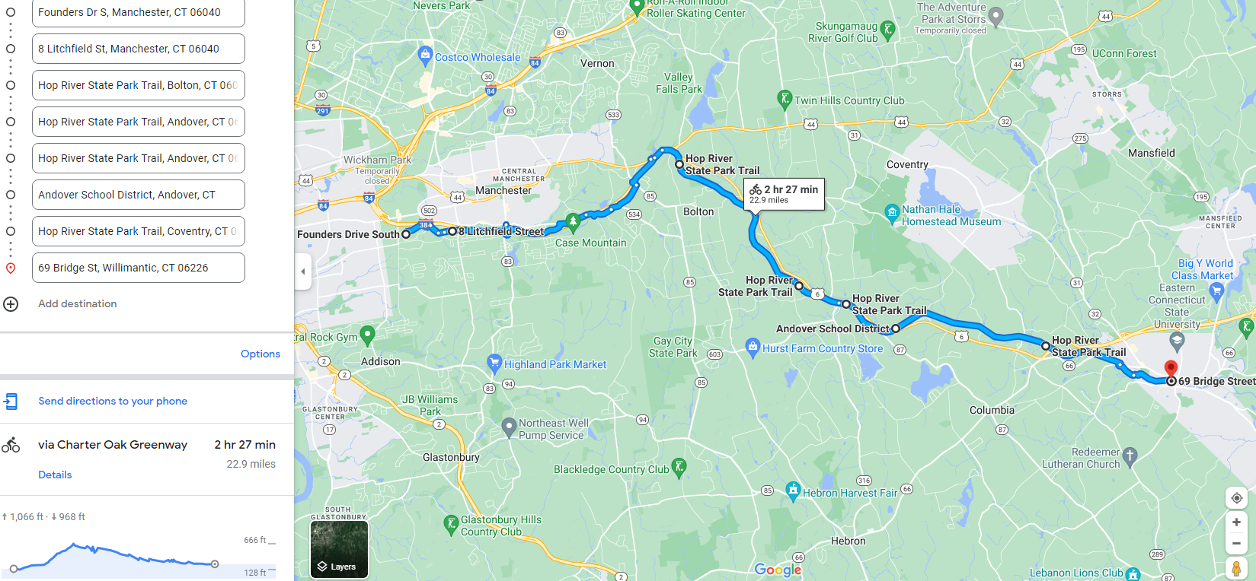
Long Ride: [out only] Start- Manchester Community College- ride Charter Oak Greenway (ECG), souh on Hop River Trail to RR Museum: Total distance 22.9 miles ride time 2 hrs 30 min.

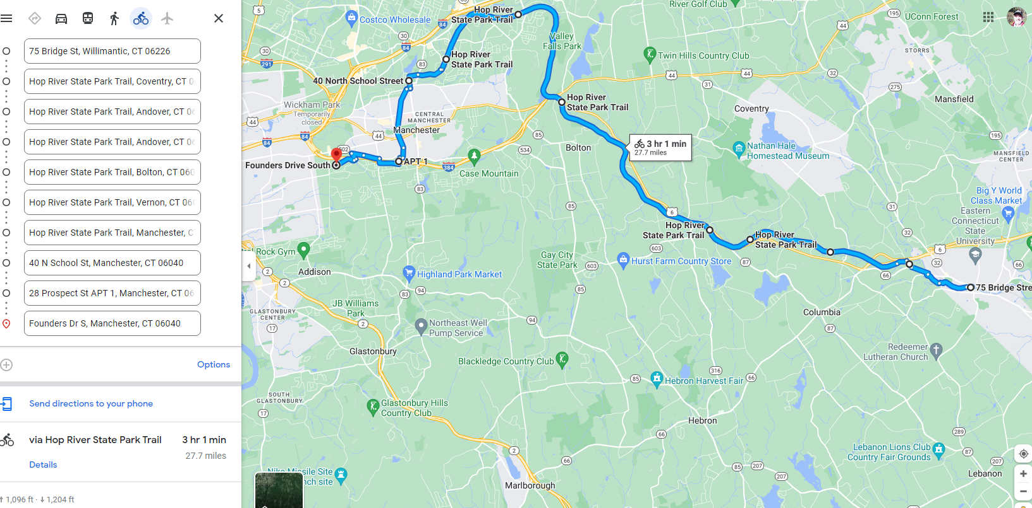
Long Ride: [return only] Railroad Museum, Hop River Trail, Cheney Rail Trail, Oak St, Hartford Rd, Prospect St- join Charter Oak Greenway- end at- Manchester Community College-Total distance 27.7 miles ride time 3 hours;
Total Long Ride: out 22.9 + back 27.7 = 50.6 miles Total time: out 2 hr 30 min, + back 3 hr = 5 hr 30 min.

