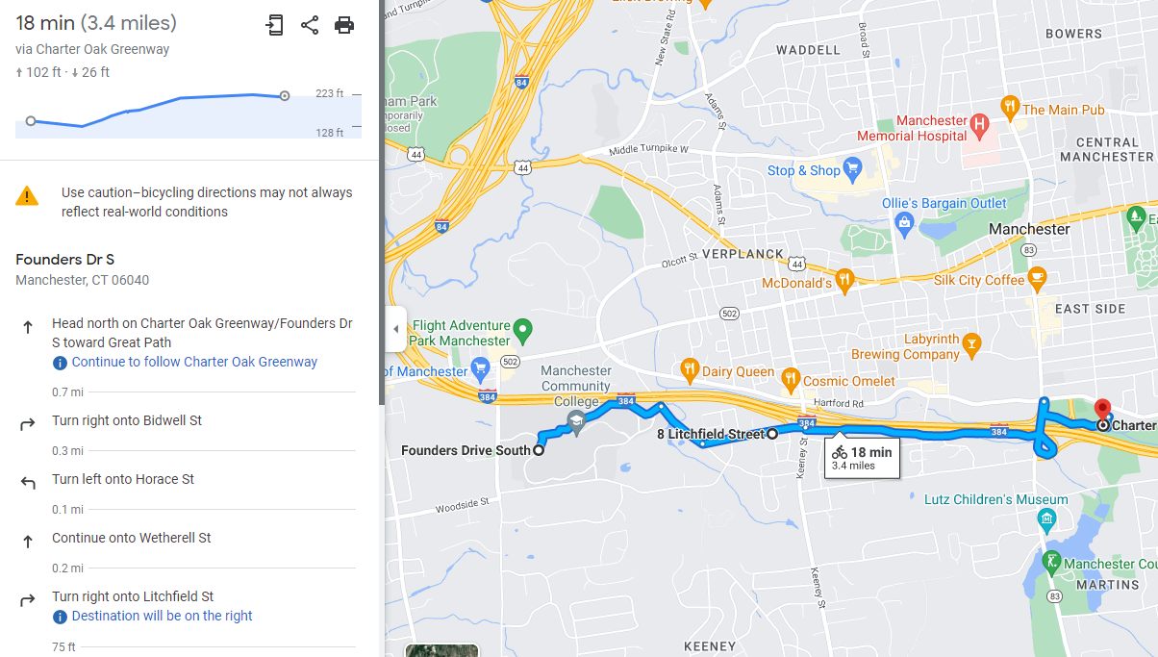Ride the East = Short Ride
Start: Manchester Community College One way 3.4 miles ro Charter Oak Greenway Park = round trip = 6.8 miles, about 40 min

